Annotation Guidelines for Social DETERMINANTS OF HEALTH
Social history sections from clinical notes will be annotated for a range of social determinants of health (SDOH), including socio-demographic, behavioral, and environmental exposure factors. The annotation involves the identification of SDOH events, where each SDOH event is represented by a trigger and set of entities. The trigger consists of a multi-word span (word or phrase) and a label indicating the type of SDOH (e.g. employment or tobacco use). Figure 1 is an example of an annotated tobacco event from the BRAT annotation tool, which will be used in this annotation project. In Figure 1, the trigger span is “smokes” and the trigger label is tobacco. This tobacco event is characterized by a status argument, consisting of a multi-word span and label indicating the tense of the event (i.e. current), as well as amount, type, frequency, and duration arguments. All annotated phenomena are defined in terms of the span (words associated with phenomena) and the span type (e.g. amount, status, etc.), and some annotated phenomena, like status, will also include a span label (e.g. current or past). If an annotated span includes a noun, the selected span should include the entire applicable noun phrase. If an annotated span includes a verb, the selected span should include applicable adverbs. The inclusion of entire noun phrases and relevant adverbs is applicable to all annotated phenomena.
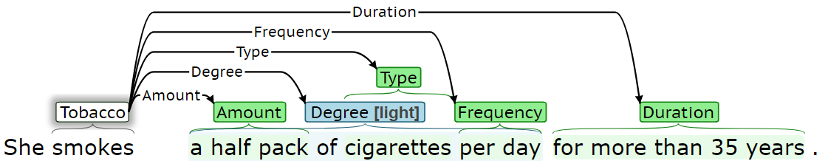
Figure 1. Annotation example
The annotated factors include:
- Socio-Demographic:
- Employment
- Living status
- Behavioral:
- Substance abuse (tobacco, alcohol, drug)
The following sections describe how each determinant will be annotated. For each annotated determinant, some entities should always be present and are required. However, some entities will not always be present. Required entities for each determinant are indicated for each determinant.

A. Socio-Demographic:

(1) Employment
Employment will be annotated with the following information:
(1) Trigger (required): The trigger is the span that most clearly indicates an employment event is present. Table 1 presents several trigger span annotation examples. The trigger span should be a work-related key phrase (e.g. “works,” “occupation,” “employed,” “unemployed,” “on disability”, “retired,” “homemaker,” etc.), if present. Otherwise, it should be a specific profession. In notes with employment-related subheadings, like “Occupation:…” or “Employment:…,” the subheading without the colon (i.e. “Occupation” or “Employment”) should be the trigger.
Table 1. Employment - trigger examples. Underlined words indicate the identified span.
Priority | Examples
1. Work-related key phrase | Occupation: Retired  She used to be employed as a registered nurse.  … she works at a nursing home.  She worked as a travel agent.  … she is retired.  … the patient is widowed and a retired engineer.  He is unemployed.  …the patient is on disability.  … the patient is a homemaker.  Currently works in construction.
2. Profession | She is a full-time student at University.  The patient is a registered nurse by profession.  She is an office manager for a gravel company.

(2) Status (required): Status annotation consists of a span selection and a label (employed, unemployed, retired, on disability, student, or homemaker). Table 2 presents status examples. Where a patient’s previous employment is described without a description of current employment, the status label should be unemployed, unless the note explicitly describes retirement, being on disability, etc. Figure 2 presents an annotated employment event, where it can be inferred that the patient is of retirement age; however, the status label should unemployed, as there is no explicit reference to retirement. In some cases, a patient’s employment status may be discussed in multiple sentences. The annotated notes will likely be processed sentence-by-sentence, and individual events should be confined to a single sentence, where possible (see “Defining Events” section at the end of this document for details). If there is an employment trigger in each sentence, then separate employment events should be created in each sentence. Figure 3 presents annotated employment events across multiple sentences, where the first sentence describes retirement and the second sentence describes previous work. The previous employment in the second sentence in Figure 3 should be labeled as unemployed, as there is insufficient information within the sentence to assign a different label. The conflicting employment status labels in the first and second sentences will be resolved in downstream postprocessing, separate from the annotation process.
Table 2. Employment - type. Underlined words indicate the identified span.
Type value | Examples
employed | Occupation: works  … she works at a nursing home.  The patient is a registered nurse by profession.  Currently works in construction.
unemployed | He is unemployed.
retired | … the patient is widowed and a retired engineer.
on disability | …the patient is on disability.  He is married, on medical leave from his job…
student | She is a full-time student at University.
homemaker | … the patient is a homemaker.

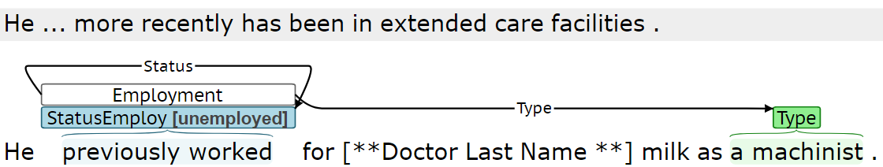
Figure 2. Employment - status example where retirement not explicitly referenced
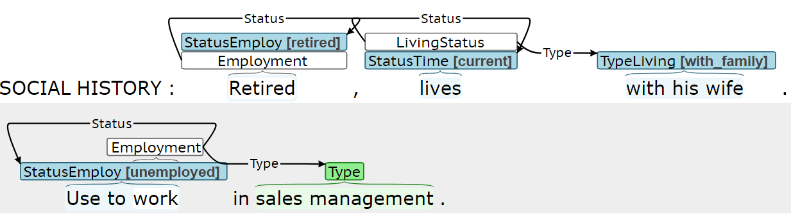
Figure 3. Employment - status example with multiple employment events across multiple sentences
(3) Duration: Duration spans describe how long the event persisted. Table 3 presents duration span examples. Duration spans will often be a prepositional phrase or adverb phrase, in which case the entire phrase should be selected. This is applicable to all determinants for which duration is a valid argument.
Table 3. Employment – duration examples. Underlined words indicate the identified span.
Examples
He works as a plumber over the last 5 years.
He has worked as a tax attorney for the past 48 years…

(4) History: History spans describe how long ago an event occurred. Table 4 presents history span examples. History spans will often be a prepositional phrase or adverb phrase, in which case the entire phrase should be selected. This is applicable to all determinants for which history is a valid argument.
Table 4. Employment - history examples. Underlined words indicate the identified span.
Examples
She stopped working more than 20 years ago due to…
She retired 7 years ago because of low back pain.
She lost her job in 2018.

(5) Type: Type indicates the occupation or profession of the patient. Table 5 presents type examples. Type span should be a specific profession, if present. Otherwise, the type should be a span that conveys the general type of work performed or location of work.
Table 5. Employment - type. Underlined words indicate the identified span.
Priority | Examples
1. Specific profession | She is currently a registered nurse and scrub technician in…  … He is employed in the military.  She is retired from running a restaurant.
2. Type of work or location of work | … he previously worked with pipeline work…  Works in a business office.

Figure 4 are example BRAT employment annotations. Figure 4 includes a single employment event; however, the employment description in Figure 5 must be represented through two separate events, to both represent the previous work in the Air Force and current work at Lockheed Martin.
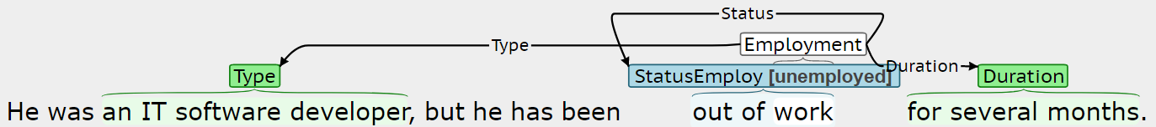
Figure 4. Employment example 1

(2) Living Status
Living status will be annotated with the following information:
(1) Trigger (required): The trigger is the span that most clearly indicates a living status event is present. Table 8 presents several trigger span annotation examples. The trigger span will likely be a form of “lives” or “resides.”
Table 8. Living status - trigger examples. Underlined words indicate the identified span.
Examples
…she lives with her husband.
The patient does live with his family.
… the patient has been living in his father’s home…
He currently lives at home with his parents.

(2) Status (required): Status indicates whether the living status event is current, past, or future. The highlighted span should be the shortest span that distinguishes between status labels. Status will often include a verb.
Table 9. Living status - status examples. Underlined words indicate the identified span.
Status label | Examples
current | He lives in a dorm there.  … patient is a resident of …  She is homeless.  He currently lives at home with his parents.
past | She was living with her parents…
future | She will be moving in with her parents for the summer.

(3) Type (required): Type annotation consists of a span selection and a label (alone, with family, with others, or homeless). Table 2 presents type examples. Type will often be a prepositional phrase.
Table 10. Living status - type. Underlined words indicate the identified span.
Type label | Examples
alone | … she lives by herself.  She lives alone at home.
with family | … he lives with parents and siblings.  Lives with her husband.  He…lives with his partner.
with others | … she…is now living in assisted living.
homeless | … is currently homeless and in need of housing…  She lives on the streets for the past 6 months.

(4) Duration: Duration spans describe how long the event persisted, for example: “for seven years” or “for the past year.”
(5) History: History spans describe how long ago an event occurred, for example: “until about a month ago” or “five years ago.”

Figure 6 and Figure 7 are example BRAT living status examples.
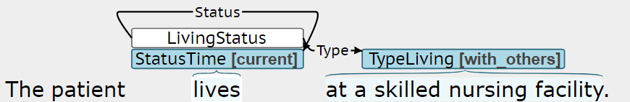
Figure 6. Living status example 1
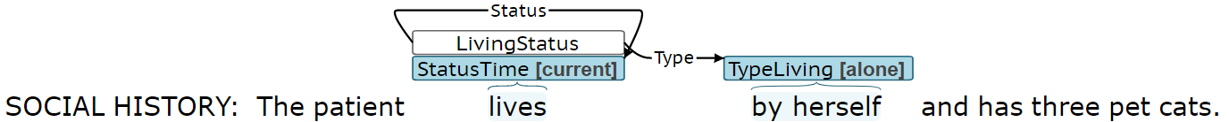
Figure 7. Living status example 2

B. Behavioral:

(1) Substance Abuse - Alcohol/drug/tobacco
Alcohol, drug, and tobacco use will be annotated. Drug events should involve marijuana, illegal drugs, or the abuse of prescription drugs. Drug events should not include the medical use (intended use) of pharmaceuticals. Only first-hand smoking should be annotated as tobacco events. Secondhand smoking should be annotated as environmental exposure. Keep in mind that alcohol may be abbreviated ETOH in chart notes.
(1) Trigger (required): The trigger is the span that most clearly indicates an alcohol, drug, or tobacco event is present. Table 19 presents several trigger span annotation examples. The trigger span should be a noun phrase describing a general substance type, like “alcohol,” “ETOH,” “tobacco history,” or “illicit drug use,” if present. If general substance types are not present, the span should be a relevant verb (e.g. “drink” or “smokes”) or a noun phrase describing a specific substance type (e.g. “cocaine” or “beer”).
Table 19. Substance trigger examples. Underlined words indicate the identified span.
Priority | Examples
1. Substance words | Alcohol none.  Does not consume alcohol.  He does not drink alcohol.  He denies tobacco use.  Tobacco history: smokes two packs…  He has a history of illicit drug use…  He used to drink alcohol rarely…  …no ETOH.
2. Verb or substance type | Admits to heroin use…  …she does not drink…  He does drink six beers a day.  He has not smoked for the past 27 years.  He does not smoke.  He has about 10 drinks a year.  …patient experimented with amphetamines, cocaine, marijuana…

(2) Status (required): Status indicates whether the substance consumption is none, current, or past. The none label indicates the patient does not use the substance currently and has not used it in the past. The highlighted span should be the shortest span that distinguishes between the status labels and will often include a verb. Table 20 presents status examples.
Table 20. Substance abuse- status examples. Underlined words indicate the identified span.
Status label | Examples
None | The patient denies any alcohol.  He currently denies any drinking.  … she does not drink…  does not consume alcohol.  No alcohol abuse.  No history of drug or alcohol abuse.  She is a nonsmoker and nondrinker.  She uses no illicit drugs.  No use of illicit drugs.  He never used…drugs  Alcohol none.
Current | She occasionally has alcohol.  He does have chronic alcohol use.  She drinks 2 to 3 glasses of wine…  Occasionally drinks.  Patient currently has 2-3 drinks per day.  He does drink six beers a day.  He is a social drinker.  She does have a history of chronic marijuana use.  Also admits today using cocaine.  He does smoke.  Social history: active smoker.  History of drinking for approximately 25 years.  Occasional alcohol use.
Past | He previously was an alcoholic…  She used to smoke…  She quit smoking in 1972.  He used cocaine in the past…  The patient experimented with amphetamines…  He admits to having smoked marijuana…  Personal history: He is an ex-smoker.  He has a history of tobacco use in the past.

(3) Duration: Duration indicates the length of time the patient used the substance(s) described in the substance event. Table 21 presents duration examples. In clinical shorthand, “x” can be interpreted as “times” or “for” and should be included in duration spans where applicable (e.g. “x 10 years”).
Table 21. Substance abuse - duration. Underlined words indicate the identified span.
Examples
She smokes 5 cigarettes per day, has done so for 10 years.
He also quit smoking cigarettes in 1984 , after 16 years of smoking.
The use of alcohol, drugs , or tobacco during the pregnancy were denied.
...the patient had a long history of smoking but quit many years ago.
She quit smoking 3 years ago after 18 years of heavy smoking.
Tobacco : smokes 4 packs / day x ~40 years .

(4) History: History indicates when a patient quit using a given substance. Table 22 presents history examples.
Table 22. Substance abuse - history. Underlined words indicate the identified span.
Examples
…used to smoke a pack a day and quit in 1985.
…the patient had a long history of smoking but quit many years ago.
…he stopped using drugs when he was 25.
She quit smoking 3 years ago after 18 years of heavy smoking.

(5) Method: Method indicates how the substance is used by the patient. Table 23 presents method examples. Method does not need to be annotated for alcohol, as method is always oral (drinking). The method for tobacco use is assumed to be smoke, and only non-smoking tobacco use methods, like chewing or vaping, need to be annotated.
Table 23. Substance abuse - method. Underlined words indicate the identified span.
Examples
He chews tobacco…

(6) Type: Type indicates the specific type of substance used by the patient, beyond the general substance categories of alcohol, drug, and tobacco. Table 24 presents type examples.
Table 24. Substance abuse - type. Underlined words indicate the identified span.
Examples
He smokes pipe.
She drinks wine a few drinks a month.
He occasionally has a beer.
…he is a non-cigarette smoker.
… but dips (smokeless) tobacco.
He used cocaine in the past…
No history of recreational drug use.
He denies alcohol or illicit drug use.
The patient experimented with amphetamines, cocaine, marijuana approximately…

(7) Amount: Amount indicates the quantity of the substance used by the patient. Table 25 presents amount examples. Amount spans are quantitative description of the substance quantity, (e.g. “three drinks” or “2 packs”) and do not include qualitative descriptions (e.g. "significant" or “heavy”). If amount includes a noun, the entire noun phrase should be selected. In general, amount spans should not include frequency information, and frequency and amount spans should not overlap.
Tobacco use is often quantified by packs per day (ppd) and pack-years. Although ppd and pack-years describe both the amount and frequency of tobacco use, ppd and pack-year references should be labeled as amount. With the exception of smoking ppd and pack-year nomenclature, amount spans should not include the frequency span information (e.g. “per day”).
Table 25. Substance abuse – amount. Underlined words indicate the identified span.
Examples
She drinks one glass of wine per day.
He drinks alcohol occasionally with up to three drinks a week.
Smoking history: smoked 1 ppd, quit…
…he has cut down to half a pack per day.
Tobacco : smokes 4 packs / day x ~40 years .
Forty pack year smoking history.

(8) Frequency: Frequency indicates how often the given substance is used by the patient. Typically, the frequency span describes how often the identified amount is used. Table 26 presents frequency examples. Frequency spans may be prepositional phrases starting with prepositions like “per” or “every.” In clinical shorthand, forward slashes, “/”, can be interpreted as “every” or per” and should be included in frequency spans where applicable (e.g. “2 drinks / day”). Qualitative descriptions like “occasional” or “rarely” will typically be annotated as part of degree, as opposed to frequency.
Table 26. Substance abuse - frequency. Underlined words indicate the identified span.
Examples
She drinks one glass of wine per day.
He drinks alcohol occasionally with up to three drinks a week.
…he has cut down to half a pack per day.
… with smoking a pack every 6 days.
The patient reports smoking marijuana a few times in his life…
Tobacco : smokes 4 packs / day x ~40 years .

(9) Degree: Degree will not be annotated.
Figure 8 is an example BRAT annotation for substance use.
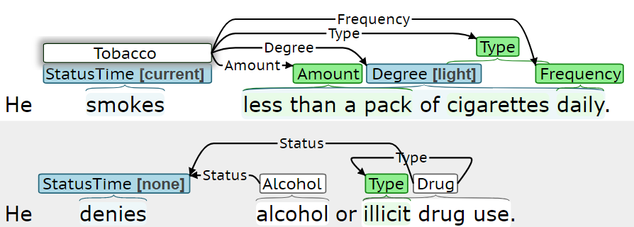
Figure 8. Substance use example

summary
This section contains a summary of all of the annotated phenomena. The social determinant information will be annotated using BRAT, which is a web-based tool. To reduce the length of some annotated phenomena, longer phenomena names have been truncated/abbreviated within the BRAT environment. Additionally, the names of some phenomena have been expanded to differentiate between different sets of labels within the BRAT environment. Table 42, Table 43, and Table 44 summarize all of the annotated phenomena. These tables include parenthetical references the specific naming convention used within BRAT. The required entities for each determinant type are highlighted in this table with a light blue background.
Table 42 presents a summary of the socio-demographic factors that will be annotated.
Table 42. Summary of socio-demographic annotation. A light blue background indicates a required entity.
Type | Entity | Labels | Span
(1) Employment | trigger | Employment  (Employment) | Employment related phrases, like “occupation,” “employed,” “works,” “retired,” “a student,” “a registered nurse,” etc.
(1) Employment | status  (StatusEmploy) | • employed  • unemployed  • retired  • on disability  • student  • homemaker | “currently works,” “a registered nurse,” “unemployed,” “medical leave,” “full-time student”
(1) Employment | duration  (Duration) | -- | Descriptions of how long event/condition persisted, e.g. “for the last five years” or patterns like:  • for <#> <time unit>  • since <date>
(1) Employment | history  (History) | -- | Descriptions of how long ago event occurred, e.g. “15 years ago” or patterns like:  • in <date>  • <#> <timeunit> ago
(1) Employment | type  (Type) | -- | Specific occupations, like “a geologist” or “registered nurse,” general types of work, like “office work.”
(3) Living status | trigger | Living status  (LivingStatus) | Phrases like “lives” or “resides.”
(3) Living status | status  (StatusTime) | • current  • past  • future | Phrases conveying tense, like “lives,” “was living,” “will be moving,” or “currently lives.”
(3) Living status | type  (TypeLiving) | • alone  • with family  •with others  • homeless | Phrases like “by herself,” “alone,” “with her husband,” “in assisted living,” “on the streets,” “couch hopping”
(3) Living status | duration  (Duration) | -- | Descriptions of how long event/condition persisted. See employment duration for examples.
(3) Living status | history  (History) | -- | Descriptions of how long ago event occurred. See employment history for examples.

Table 43 presents a summary of the socio-demographic factors that will be annotated. The annotated factors are described in more detail in the subsequent subsections.
Table 43. Summary of behavioral factor annotation.
Type | Entity | Labels | Span
(1) Substance abuse (alcohol, drug, and tobacco) | trigger | • Alcohol (Alcohol)  • Drug (Drug)  • Tobacco (Tobacco) | Phrase describing general substance (i.e. alcohol, tobacco, or drug), substance-related verb (e.g. “drinks” or “smokes”), or a specific substance (e.g. “wine,” “heroin,” or “cigarettes”)
(1) Substance abuse (alcohol, drug, and tobacco) | status  (StatusTime) | • none  • current  • past | • none: “currently denies,” “does not,” “no history,” “never used,” etc.  • current: “drinks,” “occasionally drinks,” “smokes,” “smoked,” etc.  • past: “quit,” “used,” etc.
(1) Substance abuse (alcohol, drug, and tobacco) | duration  (Duration) | -- | Descriptions of how long substance used, e.g. “for the past eight years” or patterns like:  • for <#> <time unit>  • since <date>
(1) Substance abuse (alcohol, drug, and tobacco) | history  (History) | -- | Descriptions of how long ago substance was used, e.g. “seven years ago” or patterns like:  • <#> <time unit> ago  • in <date>
(1) Substance abuse (alcohol, drug, and tobacco) | method  (Method) | -- | • Alcohol: oral/drink implied, so no annotation needed  • Drug: smoke, snort, inhale, inject, etc.  • Tobacco: smoke implied, only annotate if chew or vape
(1) Substance abuse (alcohol, drug, and tobacco) | type  (Type) | -- | • Alcohol: “beer,” “wine,” “hard liquor,” etc.  • Drug: “cocaine,” “heroin,” “marijuana,” “narcotics,” etc.  • Tobacco: “cigarettes,” “cigar,” “tobacco,” “vape” etc.
(1) Substance abuse (alcohol, drug, and tobacco) | amount  (Amount) | -- | Substance-specific quantification of amount:  • Alcohol: # [of glasses/drinks/bottles/times/cans]  • Drug: <#> of times  • Tobacco: <#> [cigarettes/packs/times]
(1) Substance abuse (alcohol, drug, and tobacco) | frequency  (Frequency) | -- | Phrases like: “daily,” “monthly,” “yearly,” etc.

Defining events
Each trigger span defines a new event. In most cases, the description of a determinant will be confined to a single sentence, resulting in a single trigger span and event for that determinant. A given event should only span across multiple sentences, if a sentence contains relevant event information and does not include a relevant trigger. Figure 12 presents an annotation example where a tobacco event must continue from the first sentence to second sentence, as the second sentence does not have a suitable tobacco trigger span. In other words, the second sentence in Figure 12, by itself, lacks sufficient information to know tobacco use is being described. Figure 13 presents an annotation example where alcohol use is described in two consecutive sentences; however, there is a suitable alcohol trigger in both sentences, so separate alcohol events should be created.
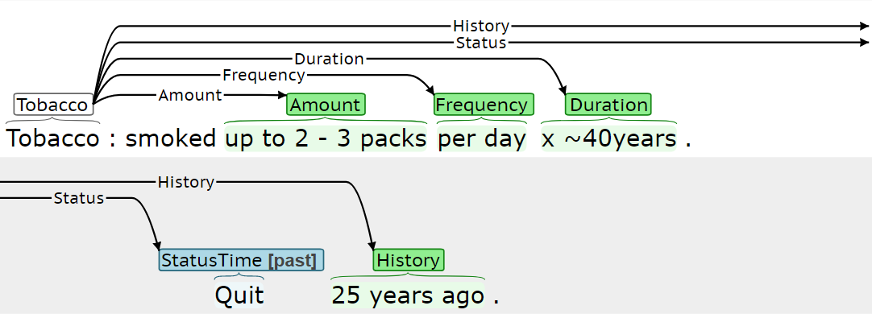
Figure 12. Example of multi-sentence Tobacco event

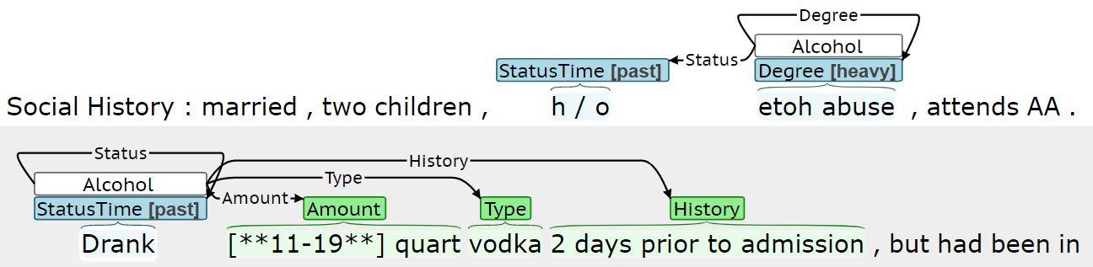
Figure 13. Example of multiple Alcohol events in consecutive sentences
In some cases, multiple events for a given determinant may need to be created within a single sentence. Figure 14 presents an annotation example where a patient’s current and previous tobacco usage is described. The amount is described for both the current and historical usage, and creating separate events for the current and previous usage allows this amount information to be better characterized.
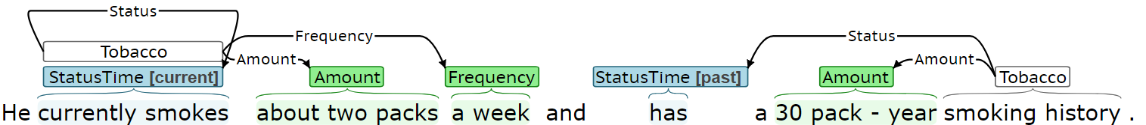
Figure 14. Example of multiple tobacco events within the same sentence

